Electronic Supplementary Material 2: Supplementary Information for Case Study 2

Summary Statistics for Case Study 2

Here, we give basic summary statistics for Case Study 2. Table 7 displays the sample size and percentage of observations in each category for the categorical variables. Table 8 displays the variable importance for a random forest run on this dataset. As discussed in the paper, age is the most useful predictor.
Table 7
Summary Statistics for Case Study 2
Baseline characteristic
Baseline characteristic | n | %
Gender
Female | 115 | 11
Male | 888 | 89
Race
Black | 25 | 2
non-Black | 978 | 98
Prior History
Prior Arrest | 856 | 85
Prior Drug Arrest | 724 | 72
Prior Felony Arrest | 721 | 72
Prior Felony Drug Arrest | 555 | 55
Prior Conviction | 673 | 67
Prior Drug Conviction | 551 | 55
Prior Felony Conviction | 541 | 54
Prior Felony Drug Conviction | 429 | 43
Charge
Possession with intent to distribute | 469 | 47
Distribution | 618 | 62
Additional non-drug charge | 129 | 13
Drugs involved
Cocaine | 401 | 40
Marijuana | 191 | 19
Crack | 197 | 20
Heroin | 264 | 26
PCP | 47 | 5
Other Drug | 33 | 3
Note. N = 1,003. Defendants were on average 33.09 years old (SD: 11.25).
Table 8
Variable Importance of Covariates for Case Study 2
Covariate | Importance
Age | 0.504
Additional Non Drug Charge | 0.039
Drug: Cocaine | 0.038
Charge: Possession with Intent to Distribute | 0.038
Gender | 0.035
Charge: Distribution | 0.033
Drug: Crack | 0.031
Drug: Marijuana | 0.030
Drug: Heroin | 0.030
Prior History: Prior Felony Arrest | 0.027
Prior History: Prior Felony Conviction | 0.025
Prior History: Prior Drug Felony Arrest | 0.025
Prior History: Prior Drug Arrest | 0.023
Prior History: Prior Conviction | 0.023
Prior History: Prior Drug Conviction | 0.022
Prior History: Prior Arrest | 0.018
Prior History: Prior Felony Drug Conviction | 0.017
Drug: PCP | 0.016
Race | 0.014
Drug: Other Drug | 0.013

Analysis of Adjusted Pair Score for Case Study 2
In this section, we provide an analysis of the adjusted pair score for Case Study 2. For this case study, the adjusted pair score has a mean of 0.500, a standard deviation of 0.269, and a correlation of -0.023 with the outcome of interest. Figure 3 gives the distribution of the adjusted pair score. Table 9 displays the correlation of each covariate with our adjusted pair score. We see that the correlations are highest for the prior history variables, matching our assessment that the LLM bases its predictions strongly on these variables. Age is also slightly correlated, but the correlation is much smaller than the prior history variables.
Figure 3: Histogram of Adjusted Pair Score for Case Study 2
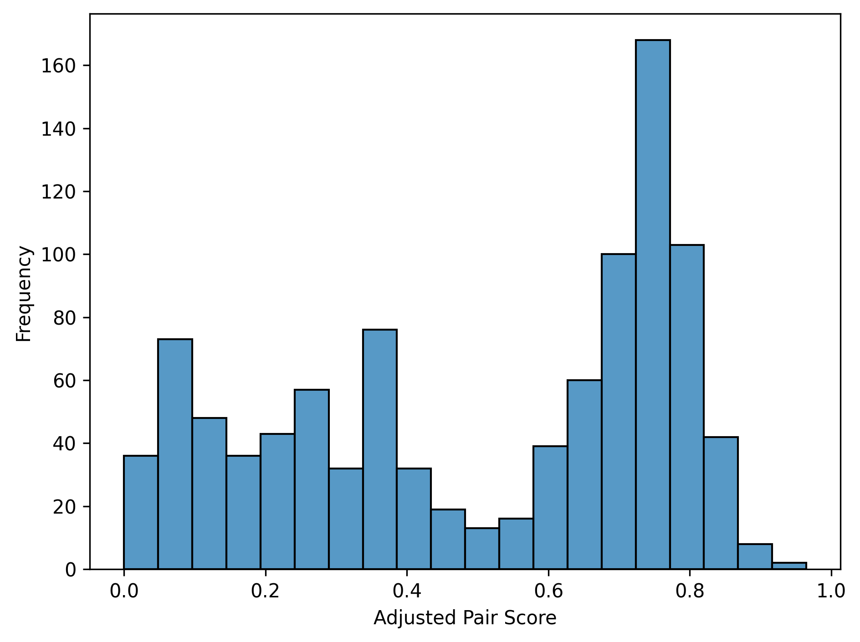

Table 9
Covariate Correlation with Adjusted Pair Score for Case Study 2
Covariate | Correlation with Adjusted Pair Score
Age | 0.277
Gender: Female | -0.277
Race: Black | -0.110
Prior Arrest | 0.644
Prior Drug Arrest | 0.668
Prior Felony Arrest | 0.795
Prior Drug Felony Arrest | 0.751
Prior Conviction | 0.806
Prior Drug Conviction | 0.730
Prior Felony Conviction | 0.914
Prior Drug Felony Conviction | 0.759
Possession with intent | -0.022
Distribution | 0.052
Additional Non Drug Charge | -0.056
Drug: Cocaine | -0.087
Drug: Marijuana | -0.058
Drug: Crack | -0.056
Drug: Heroin | 0.225
Drug: PCP | -0.044
Drug: Other Drug | -0.056

Additional Results for Case Study 2
Table 10 compares a logistic model with and without the adjusted pair score. As discussed in the paper, the adjusted pair score is not statistically significant. Table 11 gives the standard errors of the estimators with and without the adjusted pair score and Figure 4 compares these in a scatterplot. The standard errors are very similar with and without the pair score.

Table 10
Logistic Regression Results for Case Study 2
Variable | Baseline Model |  |  | LLM Model
Variable | Estimate | SE | p | Estimate | SE | p
Intercept | 1.551 | 0.494 | 0.002 | 1.576 | 0.501 | 0.002
Adjusted Pair Score |  |  |  | -0.300 | 1.442 | 0.792
OOB Predictions | 1.276 | 0.369 | 0.001 | 1.253 | 0.378 | 0.001
Age | -0.051 | 0.008 | 0.000 | -0.051 | 0.008 | 0.000
Female | -0.212 | 0.222 | 0.338 | -0.239 | 0.244 | 0.327
Black | -1.128 | 0.476 | 0.018 | -1.135 | 0.477 | 0.017
Prior Arrest | -0.433 | 0.317 | 0.172 | -0.395 | 0.348 | 0.256
Prior Drug Arrest | 0.054 | 0.286 | 0.176 | 0.078 | 0.300 | 0.795
Prior Felony Arrest | 0.578 | 0.278 | 0.038 | 0.616 | 0.313 | 0.049
Prior Felony Drug Arrest | -0.576 | 0.299 | 0.054 | -0.574 | 0.299 | 0.054
Prior Conviction | 0.213 | 0.314 | 0.497 | 0.229 | 0.319 | 0.473
Prior Drug Conviction | 0.273 | 0.317 | 0.389 | 0.289 | 0.323 | 0.371
Prior Felony Conviction | -0.452 | 0.310 | 0.144 | -0.333 | 0.550 | 0.545
Prior Drug Felony Conviction | 0.386 | 0.336 | 0.251 | 0.383 | 0.337 | 0.256
Possession with intent | 0.138 | 0.254 | 0.586 | 0.141 | 0.255 | 0.578
Distribution | 0.193 | 0.259 | 0.456 | 0.191 | 0.259 | 0.460
Additional non-drug charge | 0.033 | 0.202 | 0.869 | 0.054 | 0.216 | 0.804
Drug: Cocaine | -0.069 | 0.242 | 0.774 | -0.044 | 0.261 | 0.867
Drug: Marijuana | 0.433 | 0.239 | 0.070 | 0.422 | 0.243 | 0.083
Drug: Crack | 0.127 | 0.271 | 0.640 | 0.161 | 0.301 | 0.592
Drug: Heroin | 0.360 | 0.259 | 0.165 | 0.392 | 0.287 | 0.172
Drug: PCP | 0.573 | 0.387 | 0.139 | 0.594 | 0.396 | 0.133
Drug: Other Drug | -0.432 | 0.458 | 0.345 | -0.416 | 0.462 | 0.368
Judge 1 | -0.878 | 0.289 | 0.002 | -0.886 | 0.290 | 0.002
Judge 2 | -0.892 | 0.293 | 0.002 | -0.897 | 0.294 | 0.002
Judge 3 | -0.387 | 0.289 | 0.180 | -0.394 | 0.290 | 0.174
Judge 4 | -0.801 | 0.284 | 0.005 | -0.804 | 0.284 | 0.005
Judge 5 | -0.547 | 0.291 | 0.060 | -0.552 | 0.291 | 0.058
Judge 6 | -0.436 | 0.305 | 0.153 | -0.440 | 0.306 | 0.150
Judge 7 | -0.826 | 0.295 | 0.005 | -0.831 | 0.296 | 0.005
Judge 8 | -0.937 | 0.299 | 0.002 | -0.941 | 0.299 | 0.002

Table 11
Estimator Standard Errors for All Pairwise Comparisons
 | Judge 1 | Judge 2 | Judge 3 | Judge 4 | Judge 5 | Judge 6 | Judge 7 | Judge 8 | Judge 9
Judge 1 |  | 0.068  0.068 | 0.066  0.066 | 0.064  0.065 | 0.066  0.066 | 0.071  0.072 | 0.067  0.068 | 0.069  0.069 | 0.066  0.066
Judge 2 |  |  | 0.067  0.068 | 0.065  0.065 | 0.065  0.065 | 0.073  0.073 | 0.070  0.070 | 0.071  0.071 | 0.067  0.068
Judge 3 |  |  |  | 0.063  0.063 | 0.065  0.066 | 0.070  0.070 | 0.068  0.068 | 0.069  0.069 | 0.067  0.067
Judge 4 |  |  |  |  | 0.064  0.065 | 0.068  0.068 | 0.067  0.067 | 0.069  0.069 | 0.063  0.063
Judge 5 |  |  |  |  |  | 0.070  0.070 | 0.068  0.068 | 0.069  0.069 | 0.064  0.065
Judge 6 |  |  |  |  |  |  | 0.073  0.073 | 0.074  0.074 | 0.070  0.071
Judge 7 |  |  |  |  |  |  |  | 0.070  0.070 | 0.069  0.070
Judge 8 |  |  |  |  |  |  |  |  | 0.070  0.071
Judge 9
Note. Each upper-triangular cell reports the standard error of the estimator without the adjusted risk score (top) and the standard error of the estimator with the adjusted risk score (bottom). Standard errors are calculated assuming an equal chance of assignment to either of the two judge calendars.
Figure 4: Standard Error with Pair Score vs. Standard Error Without Pair Score

